Day in the Life of the Hudson River 10/14/21
Arbutus Lake, Newcomb & Hudson River Headwaters @ Calamity Brook
RIVER MILE: 315
Above the Salt Front: (Salt front ~ RM49)
Doug Reed & Upper Hudson and Mohawk River
4 adults total

A Journal Of Photos, Data and Stories
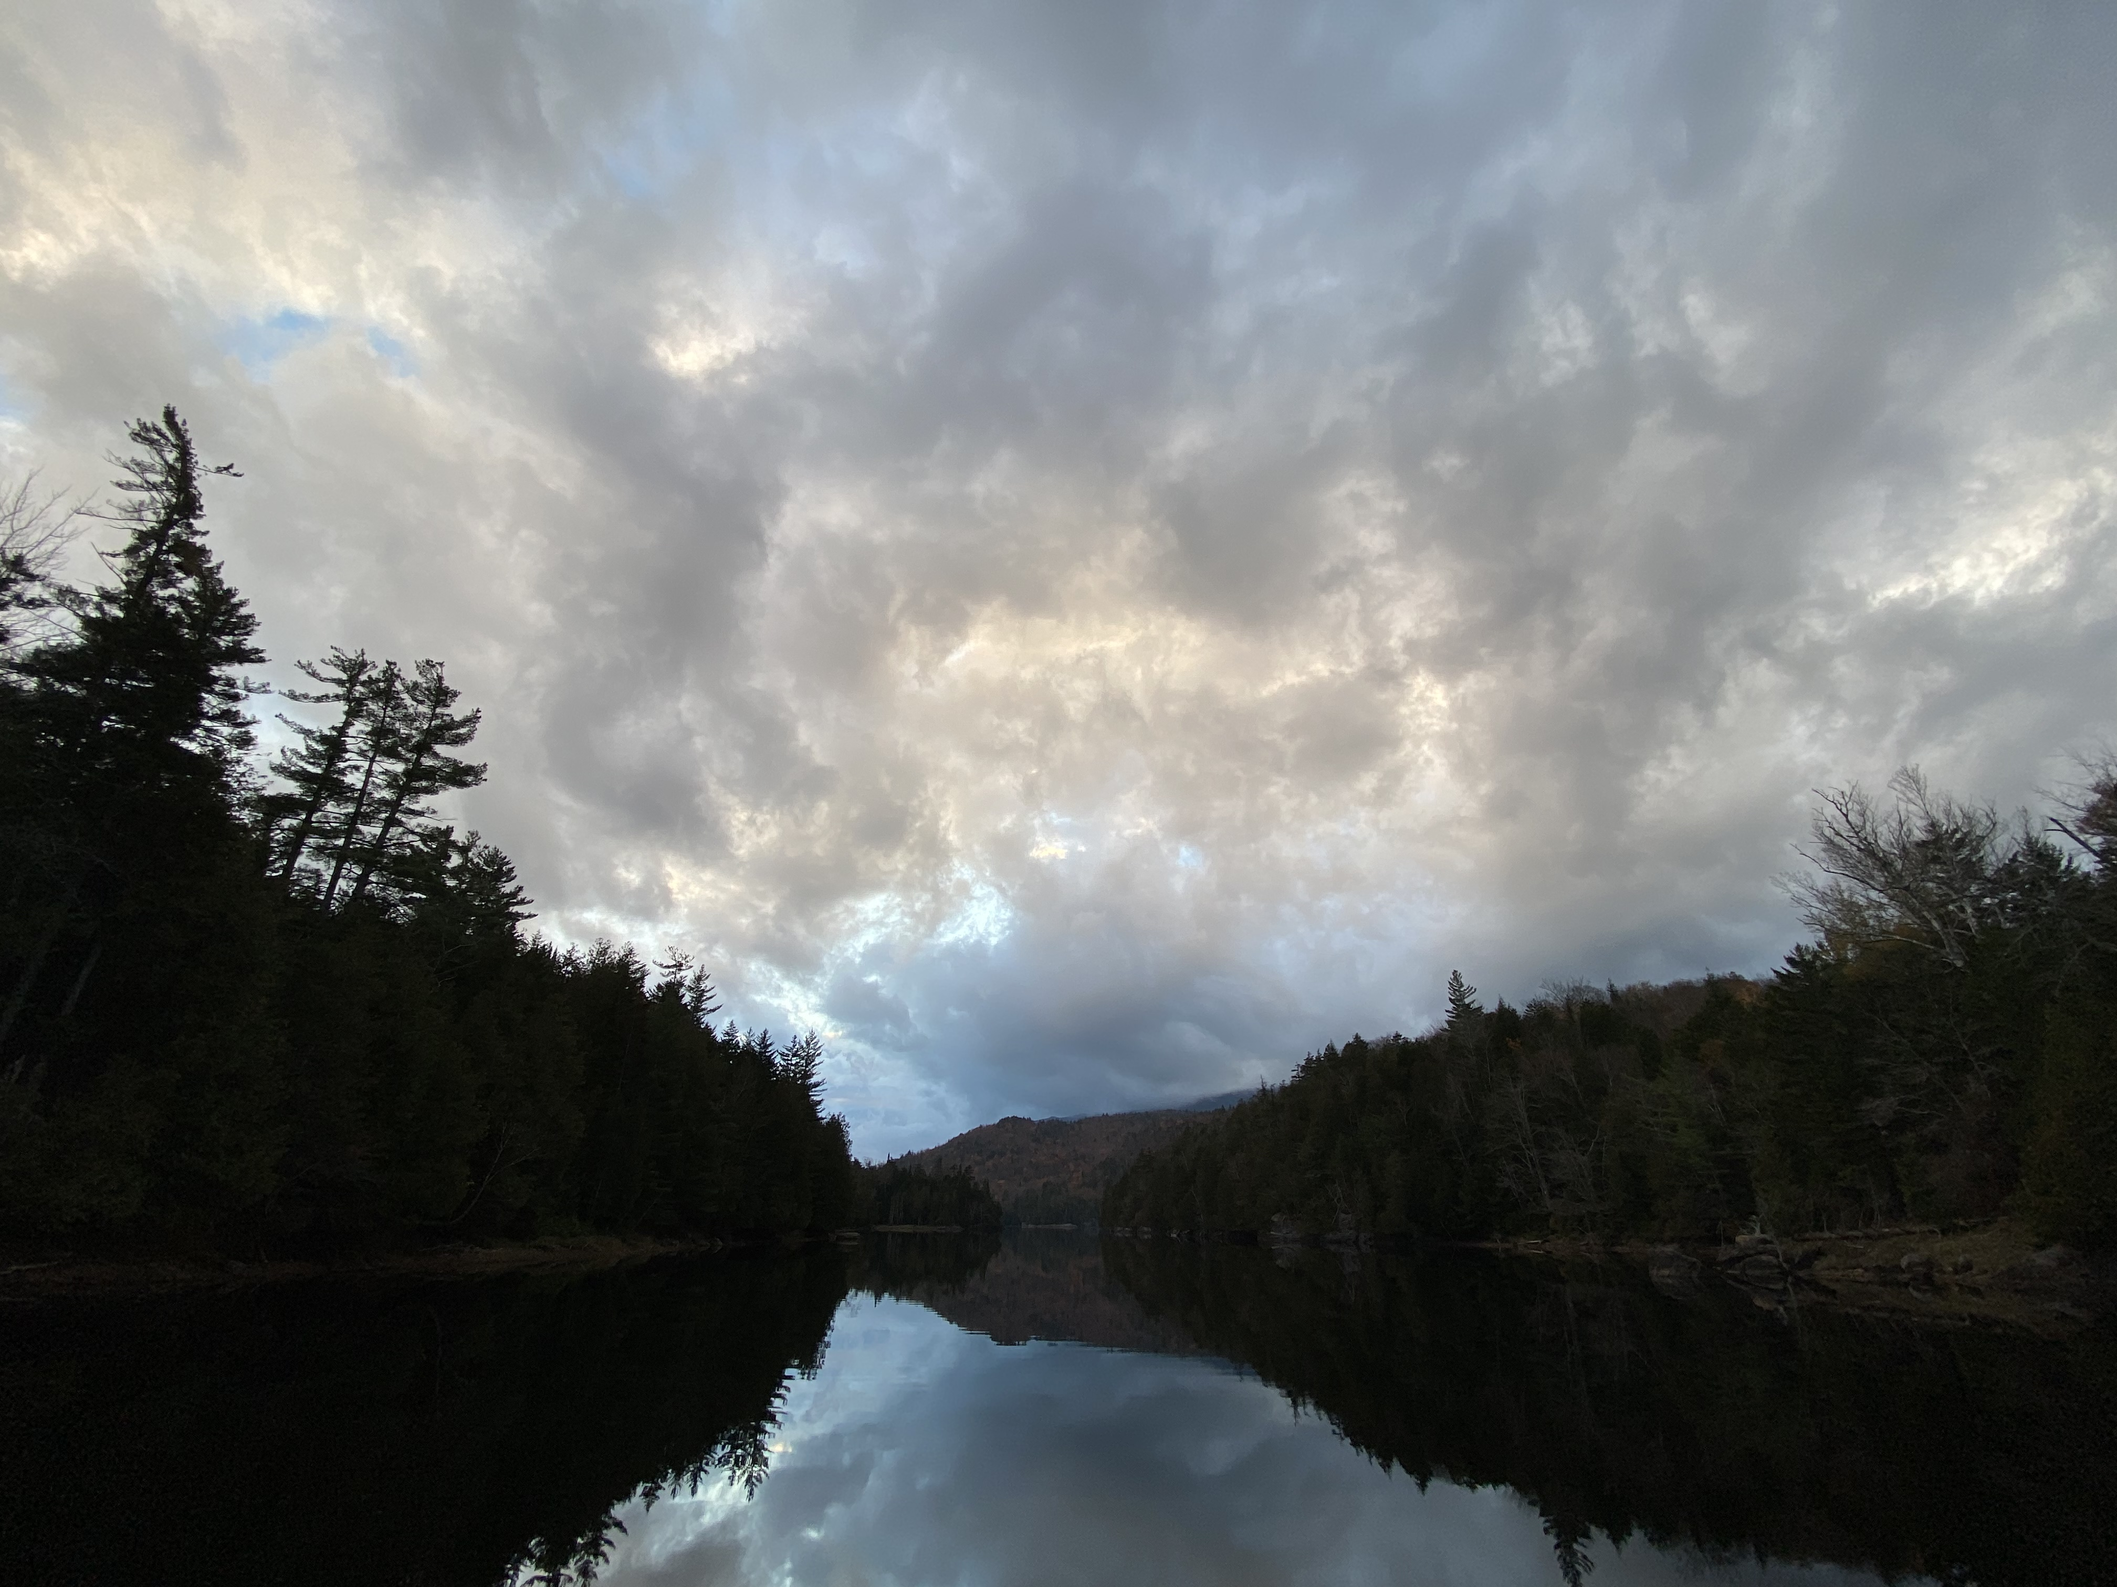
Stop #1 Arbutus Lake, Newcomb
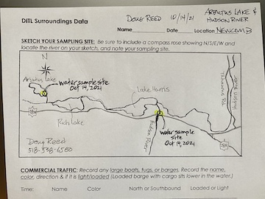
Map of Arbutus Area

Locations & Observations:
- Stop #1: @ Arbutus Lake, Newcomb, RM 315 (photo): Stunningly quiet headwater lake. No loons, two small ducks and me.

Stop #2 sampling at the bridge

- Stop #2: @Rt 28N Bridge RM 310: 20-25 Common Merganzers took off up River from under the bridge.
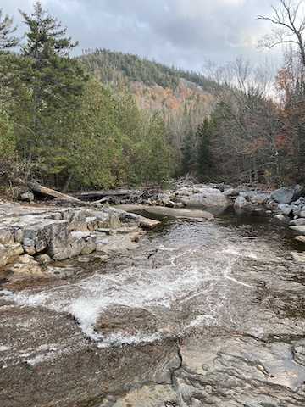
Stop #3 Calamity Brook

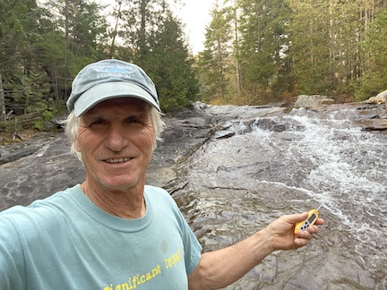
Also @ #3 - Another stop & another measurement
- Stop #3: @ Hudson River headwaters -Calamity Brook 1mile up trail from Henderson Lake RM 300: Some algae on the bedrock, boulder and cobble substrate of this waterfall site. The sound of mountain water, high-pitched across the sloping bedrock, mixes with deep pool low frequency rumbling through a narrow passage between boulders below. The carpet of sugar maple leaves on the trail smell like sweet maple sap, the essence of Adirondack Mtn headwaters.
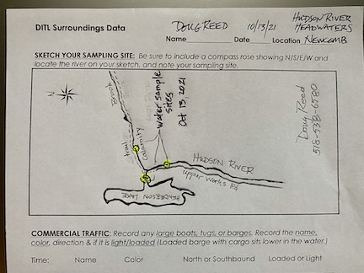

- Stop 4 @Hudson River at Newcomb, East Branch Savannah’s River at Wells, Schoharie Creek at Middleburgh

ITEM | Time | Reading |  | Comments
Physical
Air Temperature | 9:00 AM  9:20 AM  5:00 PM | furthest north  Next stop down  Next stopdown | 59.6 º F  62.5  65.5
Wind Speed: | 9:00 AM | Anemometer  5 mph | Beaufort  NR | Direction  W
Weather today | 9:00 AM | >75% cloud cover | Drizzle
Weather the past 3 days: | Warm, sunny, and overcast
Water Temperature- | 9:00 AM | 16.2º C | 61.1º F@ Newcomb  55.6 @ Calamity

